15B17CI371–Data Structures Lab ODD 2024

Week 5-LAB B Practice Lab

* 1. **Write aprogramto findwhetherthe numberisPalindrome ornot.A number is a Palindrome if it remains the same when its digits are reversed. Assumption: N is a positive integer.**

#include <iostream>

using namespace std;

int reversenum(int num, int temp)

{

if (num == 0)

return temp;

temp = (temp * 10) + (num % 10);

return reversenum(num / 10, temp);

}

bool ispalindrome(int num)

{

int reversednum = reversenum(num, 0);

return (num == reversednum);

}

int main()

{

int num;

cout << "Enter a number: ";

cin >> num;

if (ispalindrome(num))

cout << num << " is a palindrome." << endl;

else

cout << num << " is not a palindrome." << endl;

}

**Output :**

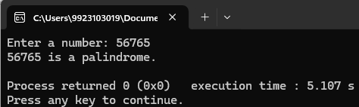

* 1. **Write a program to implement a recursive function to calculate the sum of digits of a given number.**

#include <iostream>

using namespace std;

int sum(int num,int temp)

{

if(num==0)

return temp;

else

{

temp=temp+(num%10);

return sum(num/10,temp);

}

}

int main()

{

int num;

cout << "Enter a number: ";

cin >> num;

cout<<"sum of the digits of "<<num<<" is "<<sum(num,0);

}

**Output :**

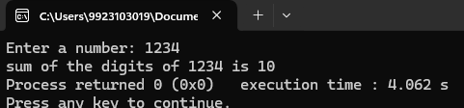

* 1. **Write a program to implement a recursive function to find the maximum and minimum elements in a given array.**

#include <iostream>

using namespace std;

int fmin(int arr[] ,int n)

{

if (n==1)

return arr[0];

return min(arr[n-1],fmin(arr,n-1));

}

int fmax(int arr[] ,int n)

{

if (n==1)

return arr[0];

return max(arr[n-1],fmin(arr,n-1));

}

int main()

{

int num;

cout << "Input the size of array : ";

cin >> num;

int arr[num];

cout<"Input the elements : ";

for(int i=0;i<num;i++)

cin>>arr[i];

cout<<"Minimum element is "<<fmin(arr,num)<<endl;

cout<<"Maximum element is "<<fmax(arr,num);

}

**Output :**

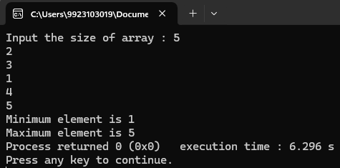

* 1. **Write a program to reverse a string using recursion.**

#include <iostream>

using namespace std;

void reverseString(string &str, int start, int end)

{

if (start >= end)

return;

swap(str[start], str[end]);

reverseString(str, start + 1, end - 1);

}

int main()

{

string str;

cout<<"Input the string : ";

getline(cin,str);

reverseString(str, 0, str.length() - 1);

cout << "Reversed string: " << str << endl;

}

**Outptut :**

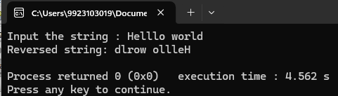

* 1. **Write a program to implement a recursive function to reverse a linked list.**

#include <iostream>

using namespace std;

struct Node

{

int data;

Node* next;

};

Node* reverseList(Node* head)

{

Node* a = head;

Node* b = head->next;

while (b->next!= NULL)

{

Node* c = b->next;

b->next = a;

a=b;

b=c;

}

b->next = a;

head ->next= NULL;

head=b;

return b;

}

void push(Node** head_ref, int new_data)

{

Node* new_node = new Node();

new_node->data = new_data;

new_node->next = (*head_ref);

(*head_ref) = new_node;

}

void printList(Node* node)

{

while (node != NULL)

{

cout << node->data << " ";

node = node->next;

}

cout << endl;

}

int main()

{

Node* head = NULL;

int n,a;

cout<<"Input the number of elements : ";

cin>>n;

cout<<"Input the elements : ";

for(int i=0;i<n;i++)

{

cin>>a;

push(&head,a);

}

cout << "Original linked list: ";

printList(head);

head = reverseList(head);

cout << "Reversed linked list: ";

printList(head);

}

**Output :**

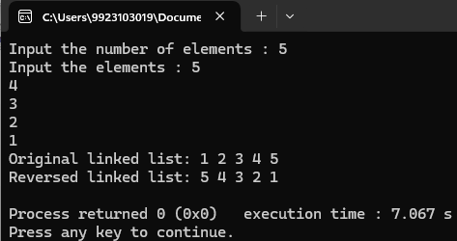

* 1. **Writeaprogramtoimplementarecursivefunctiontofindthegreatest commondivisor andLeastCommonMultiple.**

#include <iostream>

#include <string>

using namespace std;

int gcd(int a,int b)

{

if(a==0)

return b;

return gcd(b%a,a);

}

int lcm(int a,int b)

{

if(a%b==0)

return a;

else

return lcm(a+a,b);

}

int main()

{

int a,b;

cout<<"Input two numbers\na : ";

cin>>a;

cout<<"b : ";

cin>>b;

cout<<"GCD of "<<a<<" and "<<b<<" : "<<gcd(a,b);

cout<<"\nLCM of "<<a<<" and "<<b<<" : "<<lcm(a,b);

}

* 1. **Write a program to implement a recursive function to generate all permutations of a given set of numbers.**

#include <iostream>

using namespace std;

void printPermutation(int* nums, int n)

{

for (int i = 0; i < n; i++)

cout << nums[i] << " ";

cout << endl;

}

void generatePermutations(int* nums, int start, int n)

{

if (start >= n)

{

printPermutation(nums, n);

return;

}

for (int i = start; i < n; i++)

{

swap(nums[start], nums[i]);

generatePermutations(nums, start + 1, n); swap(nums[start], nums[i]);

}

}

int main()

{

int n;

cout << "Input the number of elements: ";

cin >> n;

int* nums = new int[n];

cout << "Input the elements : ";

for (int i = 0; i < n; i++)

cin >> nums[i];

cout << "All permutations are : \n";

generatePermutations(nums, 0, n);

delete[] nums;

}

**Output :**

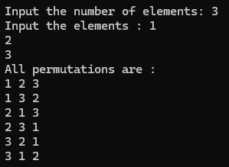

* 1. **Assume that you are given a string. You can now form continuous substrings fromthegivenstring.WriteaprogramtocountthenumberofUNIQUE continuoussetsofsubstringsthathavethesamestartingandending characters.(Youcanuseamixofrecursiveandnon-recursivefunctions).Eg:**

**Inputstring:“andisan”**

**Possiblesubstrings:**

**“a”,“an”,“and”,“andi”,“andis”,“andisa”,“andisan”,**

**“n”,“nd”,“ndi”,“ndis”,“ndisa”,“ndisan”,**

**“d”,“di”,“dis”,“disa”,“disan”,**

**“i”,“is”,“isa”,“isan”,**

**“s”,“sa”,“san”,**

**~~“a”,“an”,“n”,~~(alreadyconsideredearlier)**

**Output:7(“a”,“andisa”,“n”,“ndisan”,“d”,“i”,“s”)**

#include <iostream>

#include <string>

using namespace std;

bool isUnique(string substrings[],int count,const string &substr)

{

for (int i=0;i<count;++i)

if (substrings[i]==substr)

return false;

cout<<substr<<" ";

return true;

}

void findSubstrings(const string &str,string substrings[],int &count,int start,int end)

{

if (start>=end)

return;

if (str[start]==str[end-1])

{

string substr=str.substr(start,end-start);

if (isUnique(substrings,count,substr))

substrings[count++]=substr;

}

findSubstrings(str,substrings,count,start,end-1);

}

void countUniqueSubstrings(const string &str)

{

string substrings[100];

int count=0;

cout<<"Unique Substrings : ";

for (int i=0;i<str.size();++i)

findSubstrings(str,substrings,count,i,str.size());

cout<<"\nCount of Unique Substrings : "<<count;

}

int main()

{

cout<<"Input a string : ";

string s;

cin>>s;

countUniqueSubstrings(s);

}

**Output :**

